12.70: a) In moving to a lower orbit by whatever means, gravity does positive work, and so the speed does increase. b) 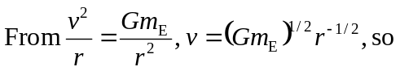
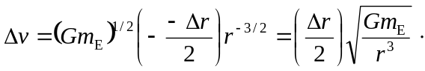

Note that a positive 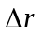is given as a decrease in radius. Similarly, the kinetic energy is
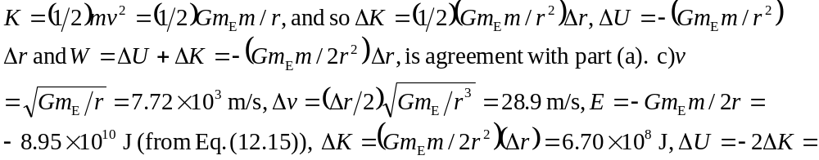
d)As the term “burns up” suggests, the energy is converted to heat or is dissipated in the collisions of the debris with the grounds.

